# **St David’s Anglican Parish of Burnside Children’s Church**

# **Activities**

**Tenth Sunday after Pentecost**

**Jesus conquers our fears**

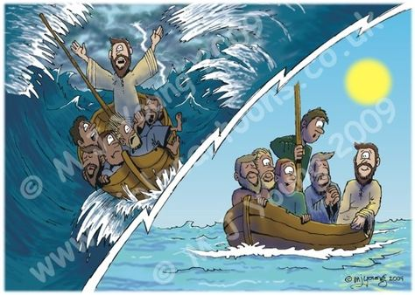

**Scripture John6:16-21**

**The Bible tells about a time when even Jesus’ friends, the disciples, were afraid. One day, they got into a boat and started making their way to the other side of the lake. Before they got to the other side, it became dark. The wind started to blow, and the water became very rough. This storm was very scary!**

**And then they saw someone walking on the stormy water toward them. They thought it was a ghost, and they were terrified!**

**Shortly after, they heard Jesus’ voice. He said, "It is I; don't be afraid." When they realized it was Jesus, they invited Him into the boat with them, and they were no longer afraid.**

Everyone’s afraid from time to time. It’s nothing to be ashamed of or to feel bad about. Even adults are afraid sometimes. That’s why it’s such great news that Jesus can conquer our fears

All of us are in the same “boat.” What I mean is that we’re all scared at times. But when we invite Jesus into our boat to be close to us, we have nothing to fear because we’re not alone.

**Prayer**

**Dear God, all of us are afraid at times. Help us to remember that with Jesus as our protector and friend, we have nothing to fear. In Jesus' name, amen.**

